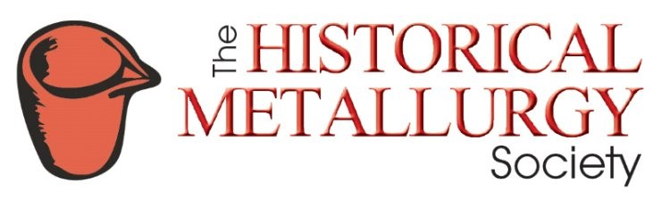

Grant Application Form

The society awards grants for research, travel and other purposes which further the aims of the society. Money from the fund is awarded in March and November; applications must be received by the end of the preceding January and September. As a guide £300–£400 is usually awarded in each round. Following an award, the results of the research undertaken or a report on the study visit must be sent to the HMS for possible inclusion in the Journal the HMS newsletter. Any unused funds must be returned to the HMS.
The grant fund was initiated by a bequest from H.H. Coghlan and from money donated by members to commemorate the life of R. F. Tylecote the renowned archaeometallurgist and founder member of the HMS. It was augmented by members’ donations to commemorate the 50th anniversary of the society.
Please emails the completed form to: grants@historicalmetallurgy.org

Title
First Name
Last Name
Address
Nationality
Date of Birth
Occupation
Institution
E-mail
Telephone
Fax
Have you previously applied HMS for a grant? |  | YES / NO

Details of application
Please give details overleaf of the research or study visit and reasons for applying to the HMS. You must include the amount applied for, a detailed estimate of the total cost, details of other grants applied for (if any), and state whether the research/visit will go ahead if no or only a partial HMS grant is awarded. If you are a student, then the name and address details of your supervisor or referee must be given. You must also give full details if you are already in receipt of an award to fund a higher degree or have an award from another grant giving body.

Grant Application Details

Title |  | First Name |  | Last Name

Signature |  | Date

